**AI-Driven Pricing and Pay is Bad for Drivers and Customers**

*Rideshare Drivers Association of Ontario (RDAO), December 2024.*

**Executive Summary 1**

**Introduction and background 1**

**The effects of AI-driven pay: evidence from screenshots 3**

**Learning from the American Experience 6**

**Recommendations 8**

# Executive Summary

On October 8, 2024, Uber changed the way it paid drivers in Ontario from a “time and distance” formula to its “Upfront pricing for drivers” model. Uber “upfront pay” is an AI-powered black box. It disconnects the fare a customer pays from the pay a driver receives: for the very same ride, passengers could potentially see higher fares while drivers receive lower pay. Different drivers may also be offered different payments for exactly the same trip, similar to ”dynamic” airline pricing – but for pay.

After hearing reports that US drivers saw earnings decrease following the introduction of AI-driven pay, the Rideshare Drivers Association of Ontario (RDAO) decided to investigate. We asked drivers to send screenshots of trip offers under the new “Upfront” scheme and compared them to what they would have received under the previous “time and distance” formula. Within a few days, drivers sent in over 200 screenshots for UberX trips.

The screenshots show our fears are justified: many Uber drivers are being paid less under the new AI-driven regime, especially those who rely on longer trips.

The problems with AI-driven pay are not just that some drivers are made significantly worse off. The proprietary and black-box nature of the algorithm means that Uber has the ability to change the algorithm at any time, and that drivers can never know the basis on which they are being paid.

While Uber argues drivers are “independent contractors,” the platform controls nearly every factor influencing a driver’s ability to earn money. The platform controls the number of drivers in a given market, affecting the amount of work drivers can get. Algorithms determine whether and how many work assignments are offered, what level of compensation to offer for each ride, and what level of commission to extract for the platform. Drivers have no control over their earnings power: working harder or for longer hours may no longer result in higher earnings.

We make three recommendations:

* An end to black-box pricing
* A return to “rate-card” pay with Toronto rates increased to match other Ontario cities
* A city-led right-sizing of the ride-hail fleet

The City of Toronto Act clearly gives the city the power to set rates and determine when and how many vehicle-for-hire licenses are issued, giving it powerful tools to help address predatory practices within the ride-hail industry.

# Introduction and background

A legal hourly minimum wage was established in Ontario in 1920 and “establishes a wage floor to prevent employers from taking unfair advantage of employees with little or no bargaining power.[1]

Even employees performing piecework or commission-based work are entitled to receive a minimum wage for their labour; workers receive the higher performance pay earned or minimum wage per time spent.[2]

With the rise of gig work, companies have begun avoiding these longstanding and hard-won labour standards, and ride-hailing services are at the forefront of the erosion of this right.

Companies like Uber have begun to erode these rights, going so far as to say that pay “varies according to the task, and that contractors are not guaranteed they will be paid the statutory hourly minimum wage for their region,” according to recent reporting by CIO.[3]

In Ontario, Uber has successfully lobbied the Ford government to exclude gig workers from the Employment Standards Act, ensuring that this fast-growing segment of our labour force - many of whom are racialized, women and newcomers - are excluded from rights that most of us enjoy and paid only for “engaged time.”[4]

In an [earlier report](https://ridefair.ca/wp-content/uploads/2024/02/Legislated-Poverty.pdf), we illustrated - using company-provided figures and City of Toronto data - that the average Uber driver in Toronto earned $6.37 per hour, well below Ontario’s minimum wage. This wage, while way too low, was still based on “rate cards,” or pay on time and kilometres travelled. In other words, there was a wage floor, which, even though it was too low, was somewhat transparent, measurable and reproducible.

Since the introduction of AI pay and AI fares by Uber in October 2024, this wage floor has disappeared; it has become virtual, ever-moving, non-transparent, immeasurable and irreproducible. Introducing this proprietary black box into Canadian wage relations sets a dangerous precedent as it evades government accountability.

|  |
| --- |
| **Figure 1: Customer vs. rider offers for the same trip** |
|  |
| *In this submission, the driver’s pre-trip gross pay (he must pay expenses and taxes out of this amount) is only 43% of the fare charged to the customer.* |
|  |

Since Uber introduced AI pay and fares in the US, research has shown that drivers’ wages declined even further, by nearly 20 percent, while fares increased above the inflation rate. In other words, Uber uses AI to squeeze workers and customers alike. In addition to that, research has shown that AI pay introduces a whole new level of algorithmic wage discrimination.[5]

This report is the first in Canada to examine sample of drivers’ trip offers and compare these to what drivers would have been paid under the previously standard “rate card system” based on time and distance. As we will show, even in this preliminary sample we find evidence that drivers’ wages are declining under this new arrangement.

Lastly, Uber’s changes are also an attempt to avoid accountability.

In Toronto, one of Uber’s largest markets in North America, the City has asked the company to provide trip data at regular intervals. Mayor Chow’s administration further directed staff to investigate drivers’ pay since poverty wages are not what builds an equitable city.

With the introduction of AI pay and fares, Uber effectively decouples what it pays drivers and charges customers from time and distance, making it impossible for regulators to establish oversight or device policies that could influence pay. And because the City allows platforms to set fares and onboard new drivers at their discretion – a role the City previously played – established platforms can also easily undercut competitors trying to do better by drivers, as has been argued elsewhere.[6]

This report details a very harmful and invasive change Uber has instituted as of October 8, 2024, makes a call to disband this form of wage discrimination and highlights the need for a dependable wage floor based on transparent, measurable and reproducible metrics.

# The effects of AI-driven pay: evidence from screenshots

Uber introduced “upfront pay for drivers” in Toronto on October 8, 2024. The Rideshare Drivers Association of Ontario asked drivers to send in screenshots of trip requests, and received over 350 screenshots.[7] Of these, over 200 screenshots for UberX trips had the required estimates of time, distance, and pay, and these screenshots form the basis of this study.

The chart below is built from these screenshots submitted to RDAO by Uber drivers. The “time and distance” pay or “rate card” pay is calculated from the values in effect up to October 8: a customer fare of $3.17 base charge, plus $0.81/km and $0.18/minute, less a 25% commission being paid to Uber.

Figure 2 compares the rate card pay (x axis) to the upfront pay. Each green dot on the chart represents a trip. The calculated “rate card” pay for the trip is shown on the x axis. The y axis shows the difference between the upfront pay and the “rate card” pay: if the upfront pay is more than the rate card pay, then the dot is in the green area; if the upfront pay is less, then the dot is in the beige area.

The computed rate card pay would have applied to most but not all trips. Some trips would have been paid at a rate higher than the standard time-and-distance rate: for example when surge pricing is in effect or on some trips out of the region. Such trips appear as outliers in the chart of upfront pay vs rate-card pay. When calculating a best fit line between the upfront and rate card pay, six trips were excluded as outliers – those with a rate card fare of over $40 AND an increase in upfront pay: those are the six trips in the top right quadrant of the chart.

## Conclusions

Our findings align with data reported by US drivers: while the occasional trip might pay more under Uber’s new system, overall, drivers are being offered less, with longer trips being paid worse under the new upfront regime than under the rate card.

A least-squares fit of upfront pay to rate-card pay gives the following:

Upfront pay = $3.71 - 0.31 * rate-card pay

In addition, there is a scattering of pay around the line, showing that the upfront pay is not just a rebalancing of pay to pay more for shorter trips, but that other unknown factors are also being used to set the pay.

## Discussion

Our sample suggests that drivers who rely on longer trips (such as many trips to and from Pearson Airport) to make a living may be more likely to see pay cuts compared to the rate card.

|  |
| --- |
| **Figure 2: Upfront pay vs rate card pay for UberX screenshots submitted by drivers.** |
|  |

In our sample, earnings for longer trips decreased 25% or more. While a large-scale study could help us better understand these trends, our sample establishes that below-rate-card fares are not only possible under Uber’s new pricing scheme – they are common.

Uber claims that it is “rebalancing” the pay between shorter trips and longer trips to incentivize drivers to accept more short trips. The screenshot data shows that this claim is true as far as it goes, but that is not very far. Regardless of any “balance” many experienced drivers know that short trips are uneconomic because of the high ratio of unpaid “en route” time to pick up the passenger compared to actual paid time. The rebalancing is insufficient to make these short trips the basis for a living wage for a full-time driver who needs to pay all the costs of running their vehicle. These experienced drivers have been relying on longer trips to provide a living wage, but that is now being taken away.

|  |  |
| --- | --- |
| **Figure 3: Examples of low upfront pay** |  |
| **Trip 1:**  Rate Card: $95.20  “Upfront rate”: $71.79 | **Trip 2:**  Rate Card: $86.60  “Upfront rate”: $65.31 |
|  |  |
|  |  |

It is worth noting that incentivizing more short-haul trips runs directly counter to the City of Toronto’s [congestion and emissions strategies](https://www.toronto.ca/services-payments/water-environment/environmentally-friendly-city-initiatives/transformto/), which seek to move 75% of all trips under 5 km to public transit or active transportation.

# Learning from the American Experience

Upfront pay for drivers was introduced to major American cities in the fall of 2022. The introduction coincided with a drop in driver earnings.[8]

|  |
| --- |
| **Figure 4: Change in US driver earnings, 2022-2023** |
|  |

The Uber Driver Earnings bar in the chart shows US data from the Gridwise Driver Assistant app. Gridwise data shows that Uber driver monthly earnings fell by 17.1% from 2022 to 2023, even though working hours fell by only 2.9%.[9]

# Recommendations

Uber’s AI-driven pricing for riders and drivers introduces a new level of precarity for drivers and sets a dangerous precedent for other industries. The City should set firm guardrails to prevent pay- and price- gouging, and ensure that Uber can’t undercut other employers trying to do right by drivers. Specifically, we recommend:

**No black-box pricing.** Uber is using AI-driven pricing for riders and drivers, with hidden algorithms, to test the limits of passenger and driver tolerance and to increase their margins.

The factors that Uber uses to set the prices of individual trips, for passengers and drivers, must be fully transparent, measurable, and reproducible.

**A return to a “rate card” pay** with actual time and distance rate structure, with an increase to match previously published rates in line with driver pay in other cities such as Windsor, Kingston and Niagara Region. The drivers in the GTA area have been receiving rates that are approximately 50% lower per km than drivers in the above regions while being in one of the most expensive cities in Ontario.

Previous Toronto Rate Card rates (UberX) = $0.81 per km + $0.18 per minute + base $3.17 less 25%

Proposed Toronto Rate Card rates (UberX) = $1.10 per km + $0.36 per minute + $4.25 base less 25% maximum

Similarly, we recommend rate card and rate changes to the other offerings like XL and other higher end and premium vehicle drivers.

**Right size the fleet.** Even with a reasonable minimum rate card in place, drivers will not be able to earn a viable income so long as ride-hail companies are permitted to continue to flood the roads with vehicles, making it impossible for drivers to obtain enough work. So long as drivers cannot earn a viable living, desirable fleet requirements such as full EV transition or replacement of accessible vehicles will be out of reach.

## Appendix: Decreasing transparency in Uber’s disclosures to drivers

Uber describes its AI-driven pricing as an increase in transparency – insofar as it lets drivers know the destination and price of a trip prior to accepting it. But there are many ways in which pay has become less transparent – drivers don’t know how earnings are calculated, for example, and at least some drivers are no longer provided invoices for trips they provide.

1. Uber records provided to drivers have changed, with some drivers no longer accessing invoices

|  |
| --- |
|  |
|  |

1. A screenshot of a computer

   Description automatically generatedPreviously, invoices provided important disclosures to drivers about their earnings

|  |
| --- |
|  |
|  |

1. 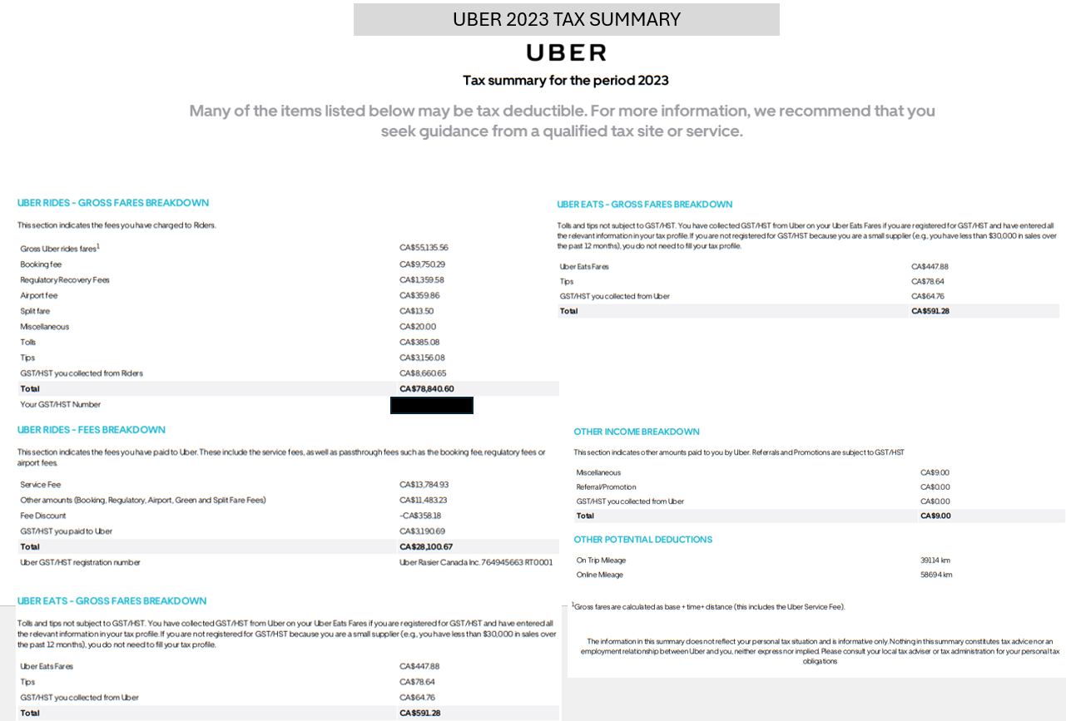 Previous disclosures available to drivers, continued

|  |
| --- |
|  |
|  |

1. Uber communications to drivers have tried to justify the relative and absolute decrease in driver earnings

|  |
| --- |
|  |
|  |

1. <https://www.ontario.ca/document/employment-standard-act-policy-and-interpretation-manual/part-ix-minimum-wage>
2. <https://www.ontario.ca/laws/statute/00e41>
3. <https://www.cio.com/article/3614626/uber-branches-out-into-ai-data-labeling.html>
4. <https://gigworkersunited.ca/bill88.html>
5. <https://papers.ssrn.com/sol3/papers.cfm?abstract_id=4331080>
6. https://openmindeconomics.substack.com/p/the-only-game-in-town-how-better
7. The data is available for viewing by the City upon request.
8. [Changes in US Employee Wages vs. Uber Driver earnings, 2022-2023 (Sherman, 2024)](https://medium.com/@ls2673/the-inconvenient-truths-ubers-ceo-doesn-t-want-you-to-know-7863852cf204)
9. See: <https://gridwise.io/gig-mobility-report/>